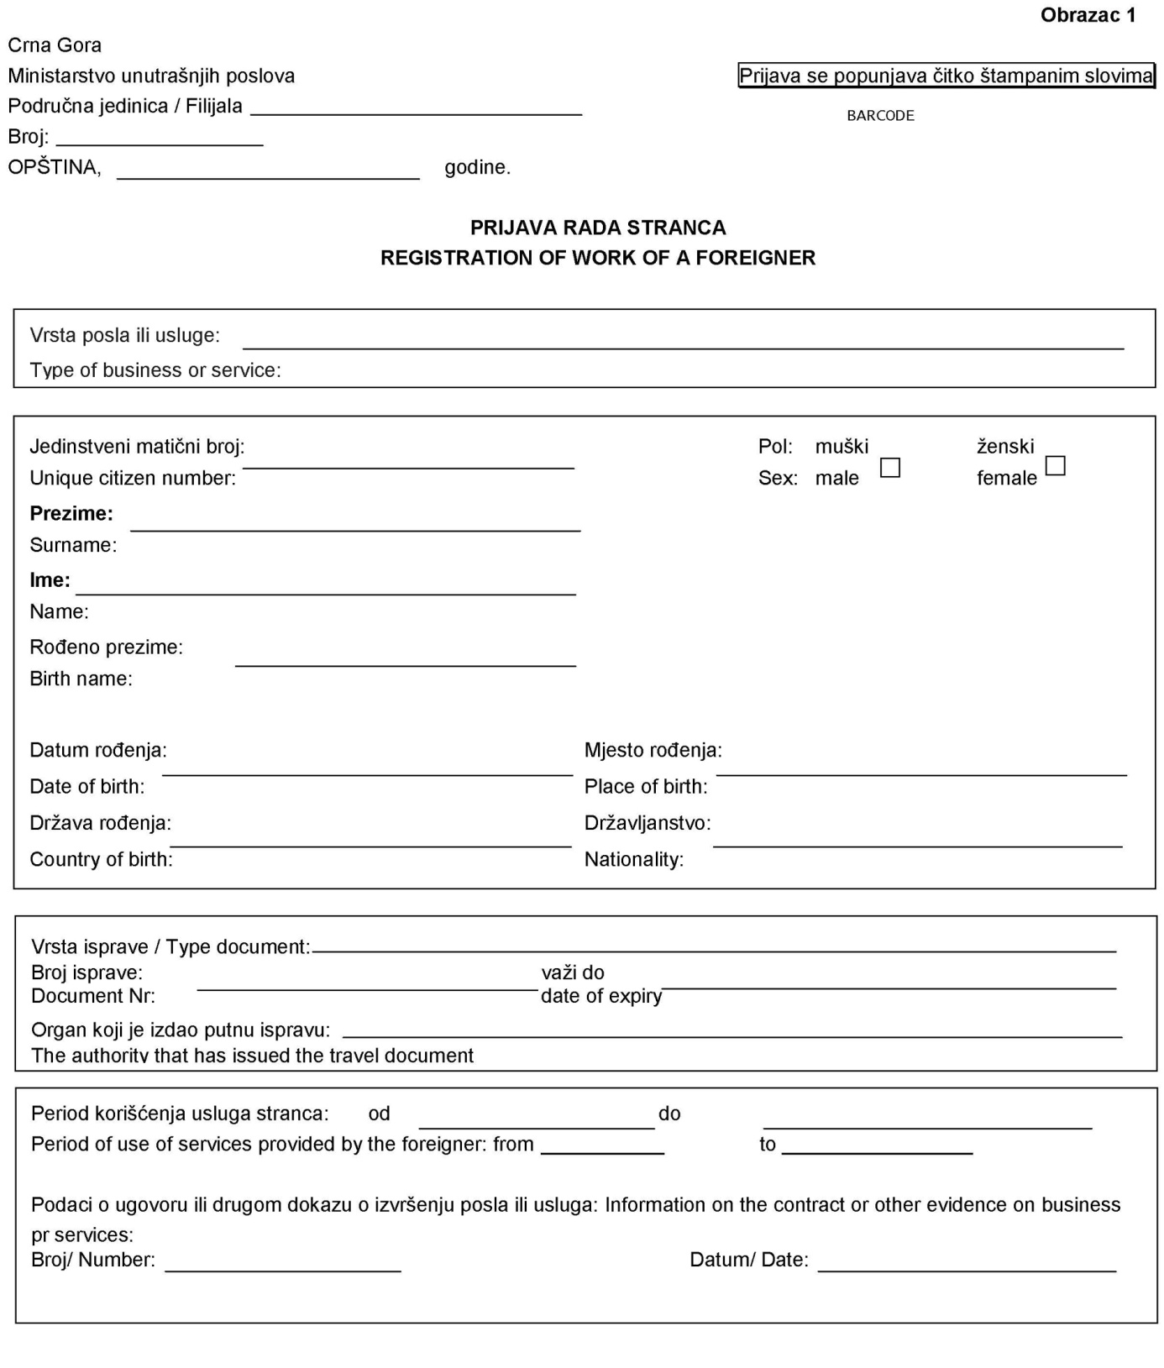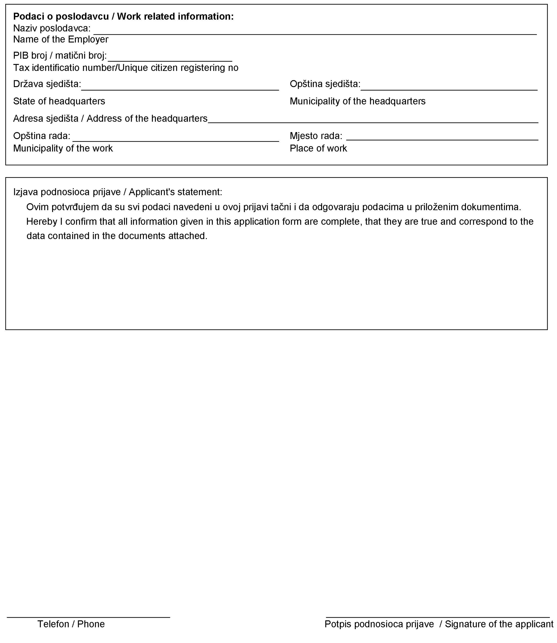

Obrazac 2

Crna Gora
MINISTARSTVO UNUTRAŠNJIH POSLOVA
Broj: ____________________od ________godine
Opština, _____________________

Na osnovu člana 81 stav 4 Zakona o strancima („Službeni list CG“, br. 56/14) Ministarstvo unutrašnjih poslova ______________________________________ izdaje

POTVRDU O PRIJAVI RADA STRANCA
FOREIGNER WORK REGISTRATION CERTIFICATE

Ime i prezime stranca
Name and surname of the foreigner ______________________________________________________

Državljanstvo
Citizenship __________________________________________________________________________

Broj strane putne isprave ili lične karte
Foreigner travel document or ID card number _____________________________________________________

Period na koji je odobren boravak i rad
Approved residence and work, from to ____________________________________________________

Vrsta posla ili usluge
Type of business activity or service _______________________________________________________

Naziv pravnog ili fizičkog lica koji koriste usluge stranca (poslodavac)
The employer or the services recipient _____________________________________________________

Broj i datum zaključenog ugovora ili drugog dokaza o izvršenju posla sa strancem ili stranim poslodavcem / Number and date of the Contract or other evidence of the work performance with a foreigner or foreign employer _____________________________

Na osnovu ove potvrde stranac za isto pravno ili fizičko lice (poslodavac) ili primaoca usluga može raditi na cijeloj teritoriji Crne Gore / On the basis of this certificate, a foreigner may work on the whole of the territory of Montenegro for the same employer or services recipient.

Pravno ili fizičko lice (poslodavac) ili primalac usluga mora u poslovnim prostorijama, odnosno mjestu rada stranca imati kopiju potvrde o prijavi rada / The employer or services recipient must have a copy of the work registration certificate in his/her business premises.

POTPIS OVLAŠĆENOG LICA
M.P

